Completion of the Application for Flight Reservations: Implemetation of Use Case for Adding Reservation and Registration of a User.

No Errors showing in code

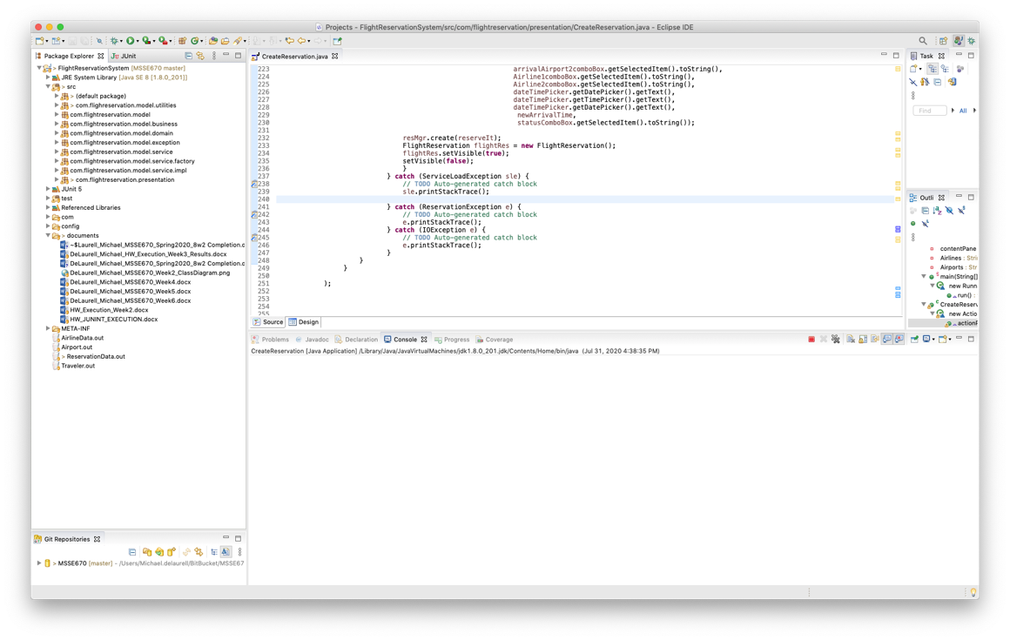

Login window – Login code not implemented as part of the Use Cases for this course.

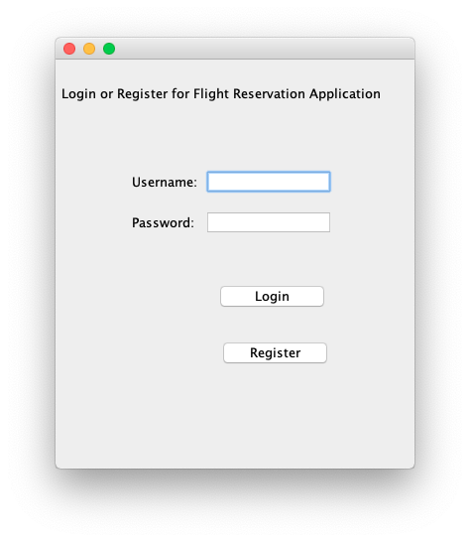

Registration Dialog: This code is implemented and adds users:

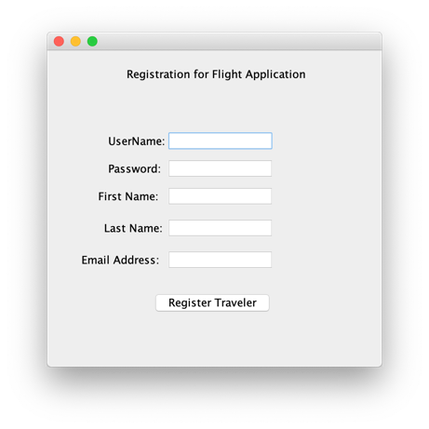

Object added to Traveler.out file:

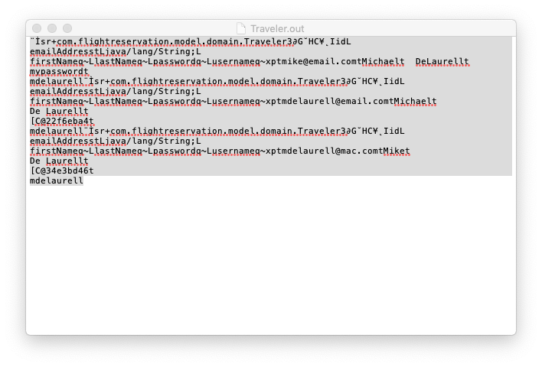

Login button takes user to Flight Reservations:

Displays Flight Reservations and allow the user to create additional flight reservations:

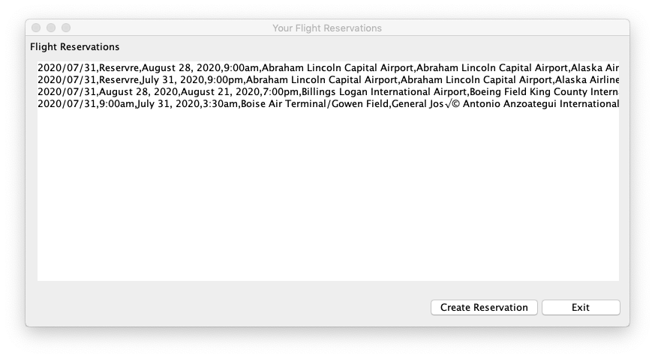

Create Flight Reservation:

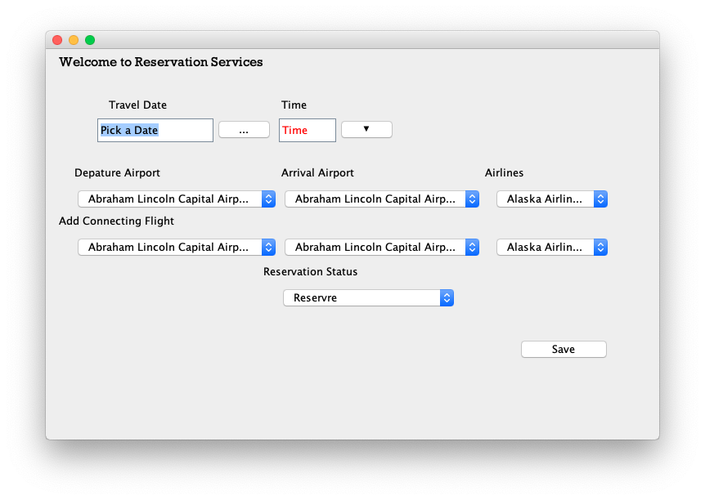

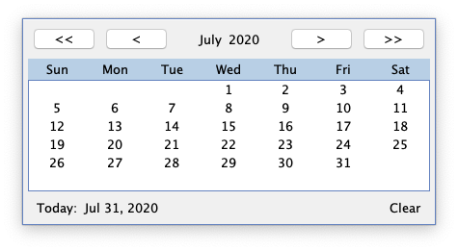

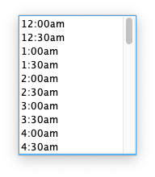

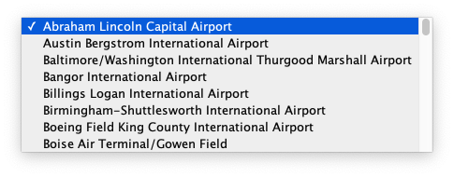

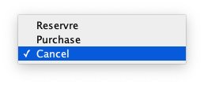

Information Added to Flight Reservations Screen

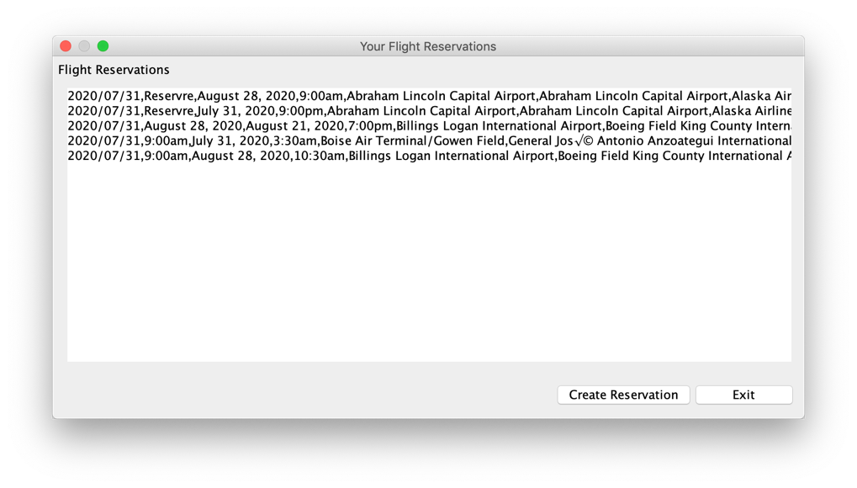

Exit button ‘Exits’ the application.

Using libraries for:

Jgoodies-forms, jgoodies-list, jgoodies-looks, jgoodies-common, LGoodDatePicker, jcalendar.

There is additional work that can be done on this application to make it work better and look better. I would move the records into a database and use this as the backend to support the reservation system. In addition, would implement a better security based on best practices in the java and security areas.